4CSO21
Introduction to Object Oriented Programming

Assignment -Week 7

Name: Roshan Karki
Group: L4CG2
Student ID: 2604786

Table of Contents
Lab | Lab Title | Page No. | Tutor’s Signature
1. | 1. Class Diagram 3  1. Write a code first and convert the code into the class diagram. 3  1.Create a Customer class: will hold basic customer information such as the first name and last name. 3  2.Create a Account class:will hold information such as the account number, account balance and will extend the customer class to allow customer details to be used within the constructor. This class will also hold functions such as deposit and withdraw. 3  3.Create a Transaction class: will hold a method called transfer to allow accounts to transfer money between them. 3  4.Create a Test class:will hold the objects of the above classes and perform the operation needed. 3

Class Diagram

Write a code first and convert the code into the class diagram.

1.Create a Customer class: will hold basic customer information such as the first name and last name.

2.Create a Account class:will hold information such as the account number, account balance and will extend the customer class to allow customer details to be used within the constructor. This class will also hold functions such as deposit and withdraw.

3.Create a Transaction class: will hold a method called transfer to allow accounts to transfer money between them.

4.Create a Test class:will hold the objects of the above classes and perform the operation needed.
Ans: -
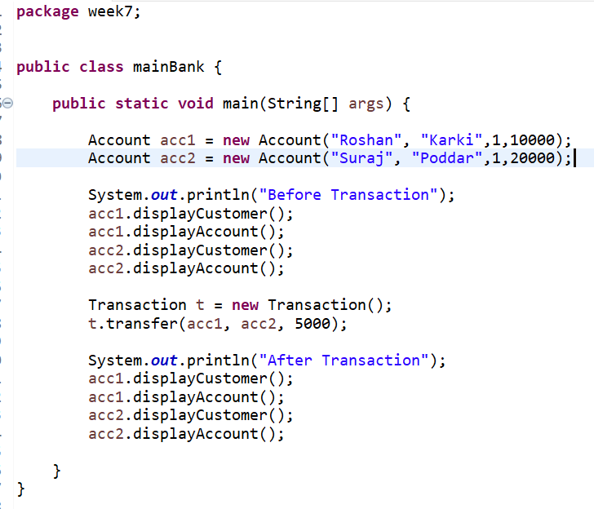
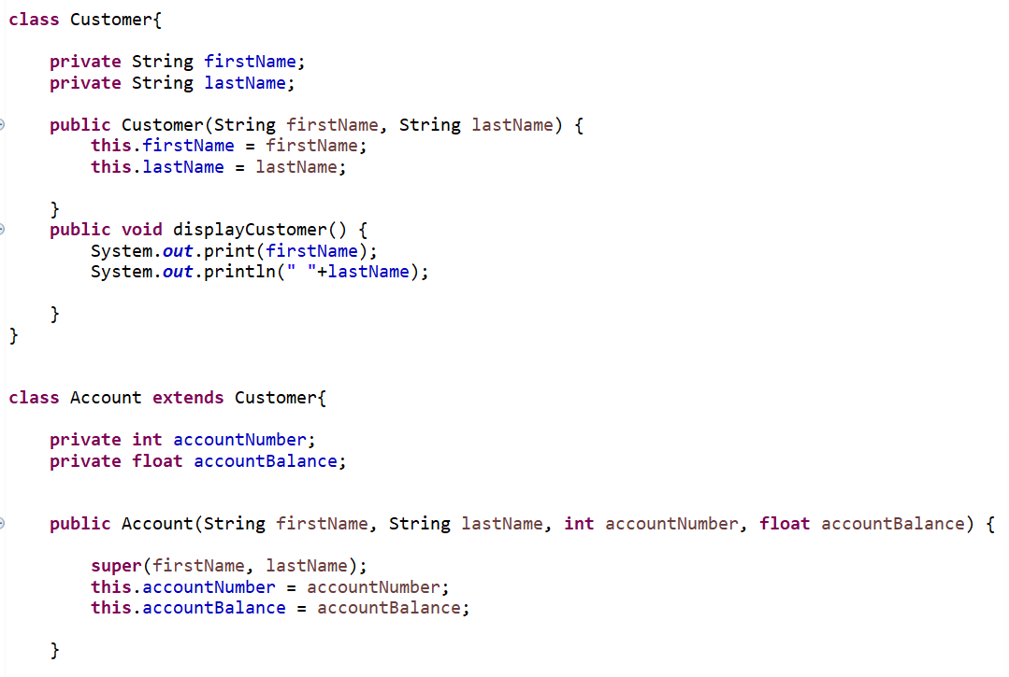
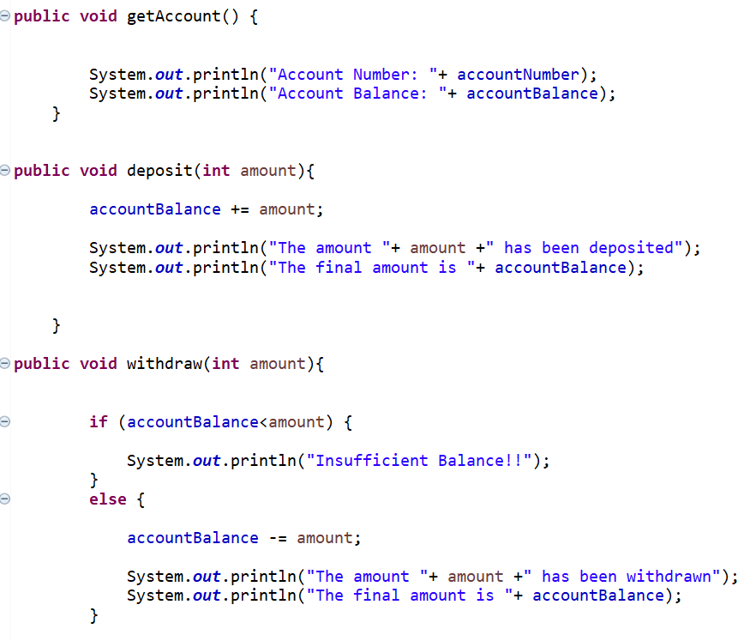


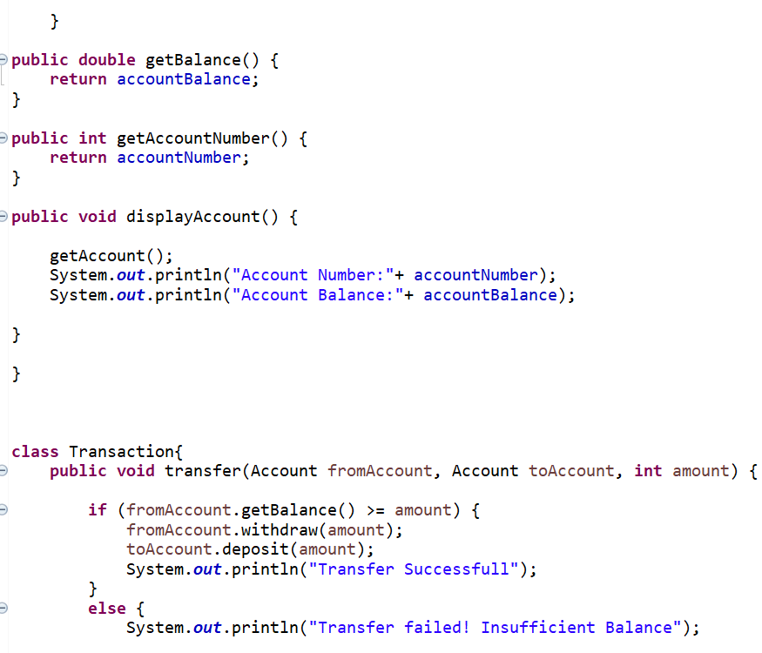
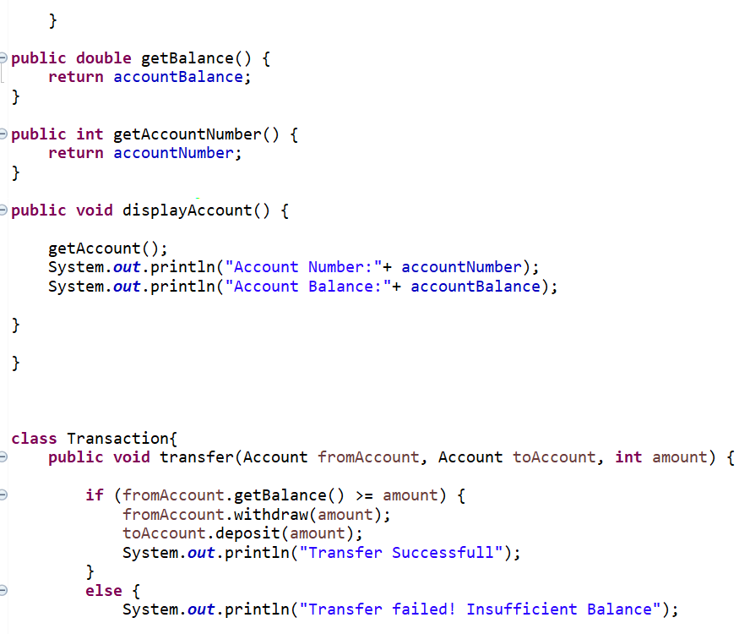
CLASS DIAGRAM:
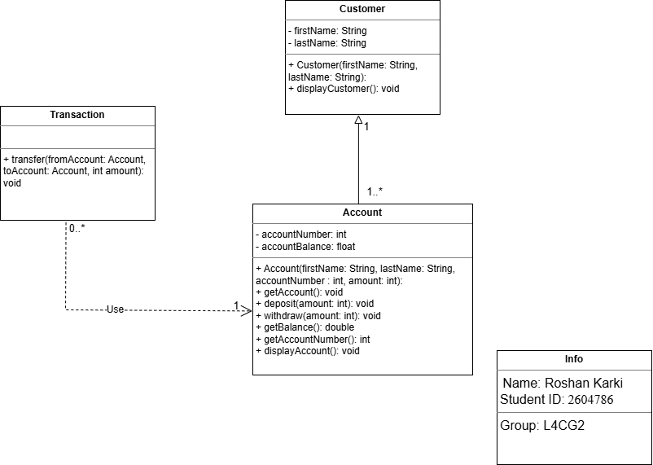

1. What are the primary actors described by the code above?
Ans: - Customer

2.What are the primary use cases (actions) described by the code above.
Ans: -
- View Customer Details
- View Account Details
- Deposit Money
- Withdraw Money
- Transfer Money
- Check Balance
- Insufficient Balance (exception)

3.Assocations in the code above.
Ans: - Customer is connected to:
- View Customer Details
- View Account Details
- Deposit Money
- Withdraw Money
- Transfer Money
- Check Balance

4.Relations (include and exclude) if needed.
Ans: - <<include>> is at: -
- Transfer Money → Check Balance
- Transfer Money → Withdraw Money
- Transfer Money → Deposit Money

<<extend>> is at: -
- Withdraw Money → Insufficient Balance

5.Perform steps 1-4 and convert it to use Case diagram.
USE CASE DIAGRAM:
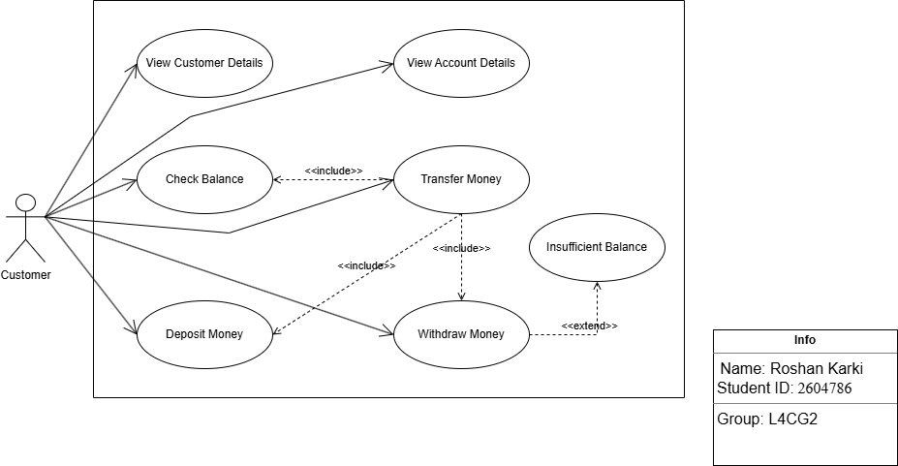
SEQUENCE DIAGRAM:

1.What are the objects involved in the banking system above?
Ans: -
- Customer
- Transaction
- Account A
- Account B

2.Observe and find the sequence of the code for sequence diagram.
Ans: -

3.Are there any synchronous and asynchronous messages?
Ans: - All of the messages on this program uses synchronous messages. There is no asynchronous messages.

4. What are the possible responses?
Ans: - The possible responses are:
- Responses from display methods:
- displayCustomer():
- “Roshan Karki”
- “Suraj Poddar”
- displayAccount():
- Account Number :1
- Account Balance: 1000
- Responses from transaction:
- The amount 5000 has been withdrawn
- The final amount is …
- The amount 5000 has been deposited
- The final amount is …
- Transfer Successful
- Transfer Failed! Insufficient Balance

5.Perform steps mentioned above and convert it to sequence diagram?

Ans: -
